Emre Can Şen- 21902516

Section-2

Lab-05

Analytical Part

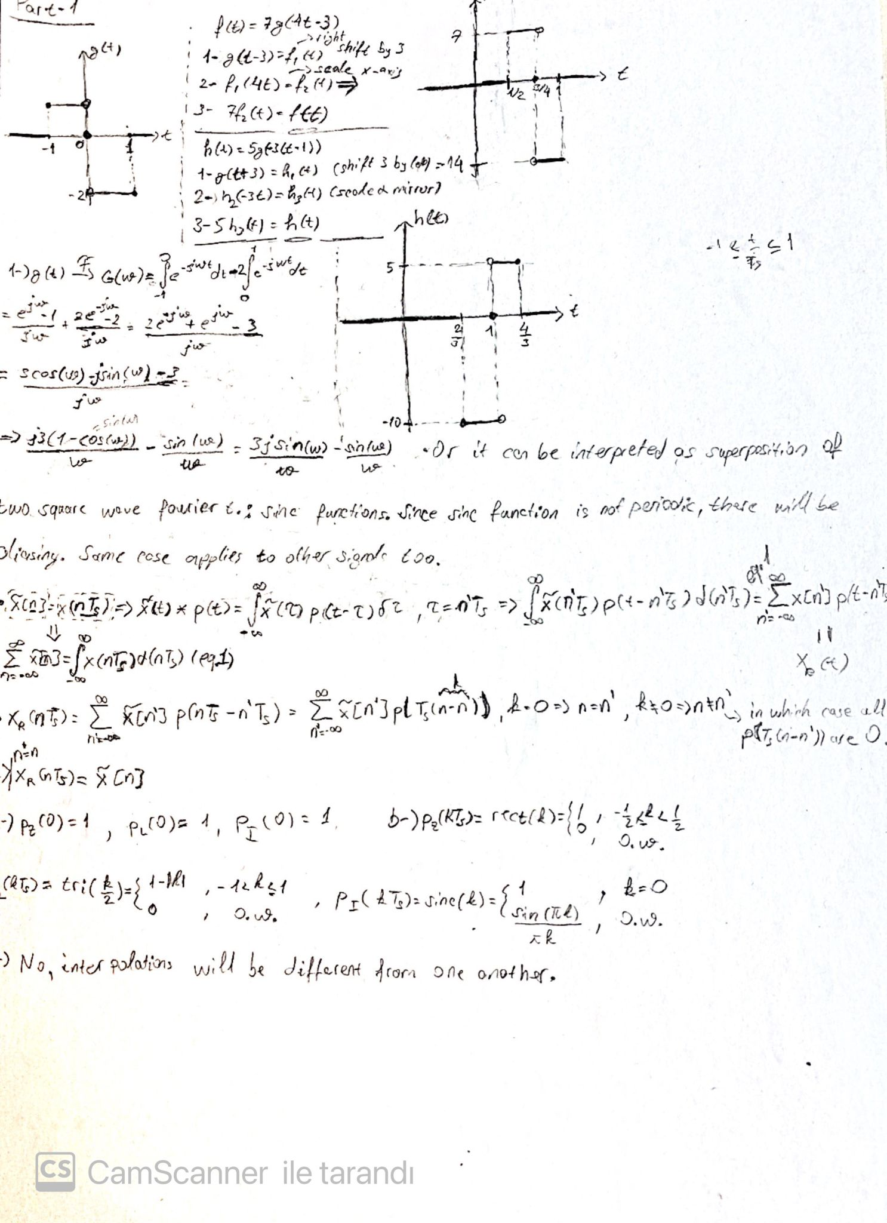

Figure 1- Analytical Part 1

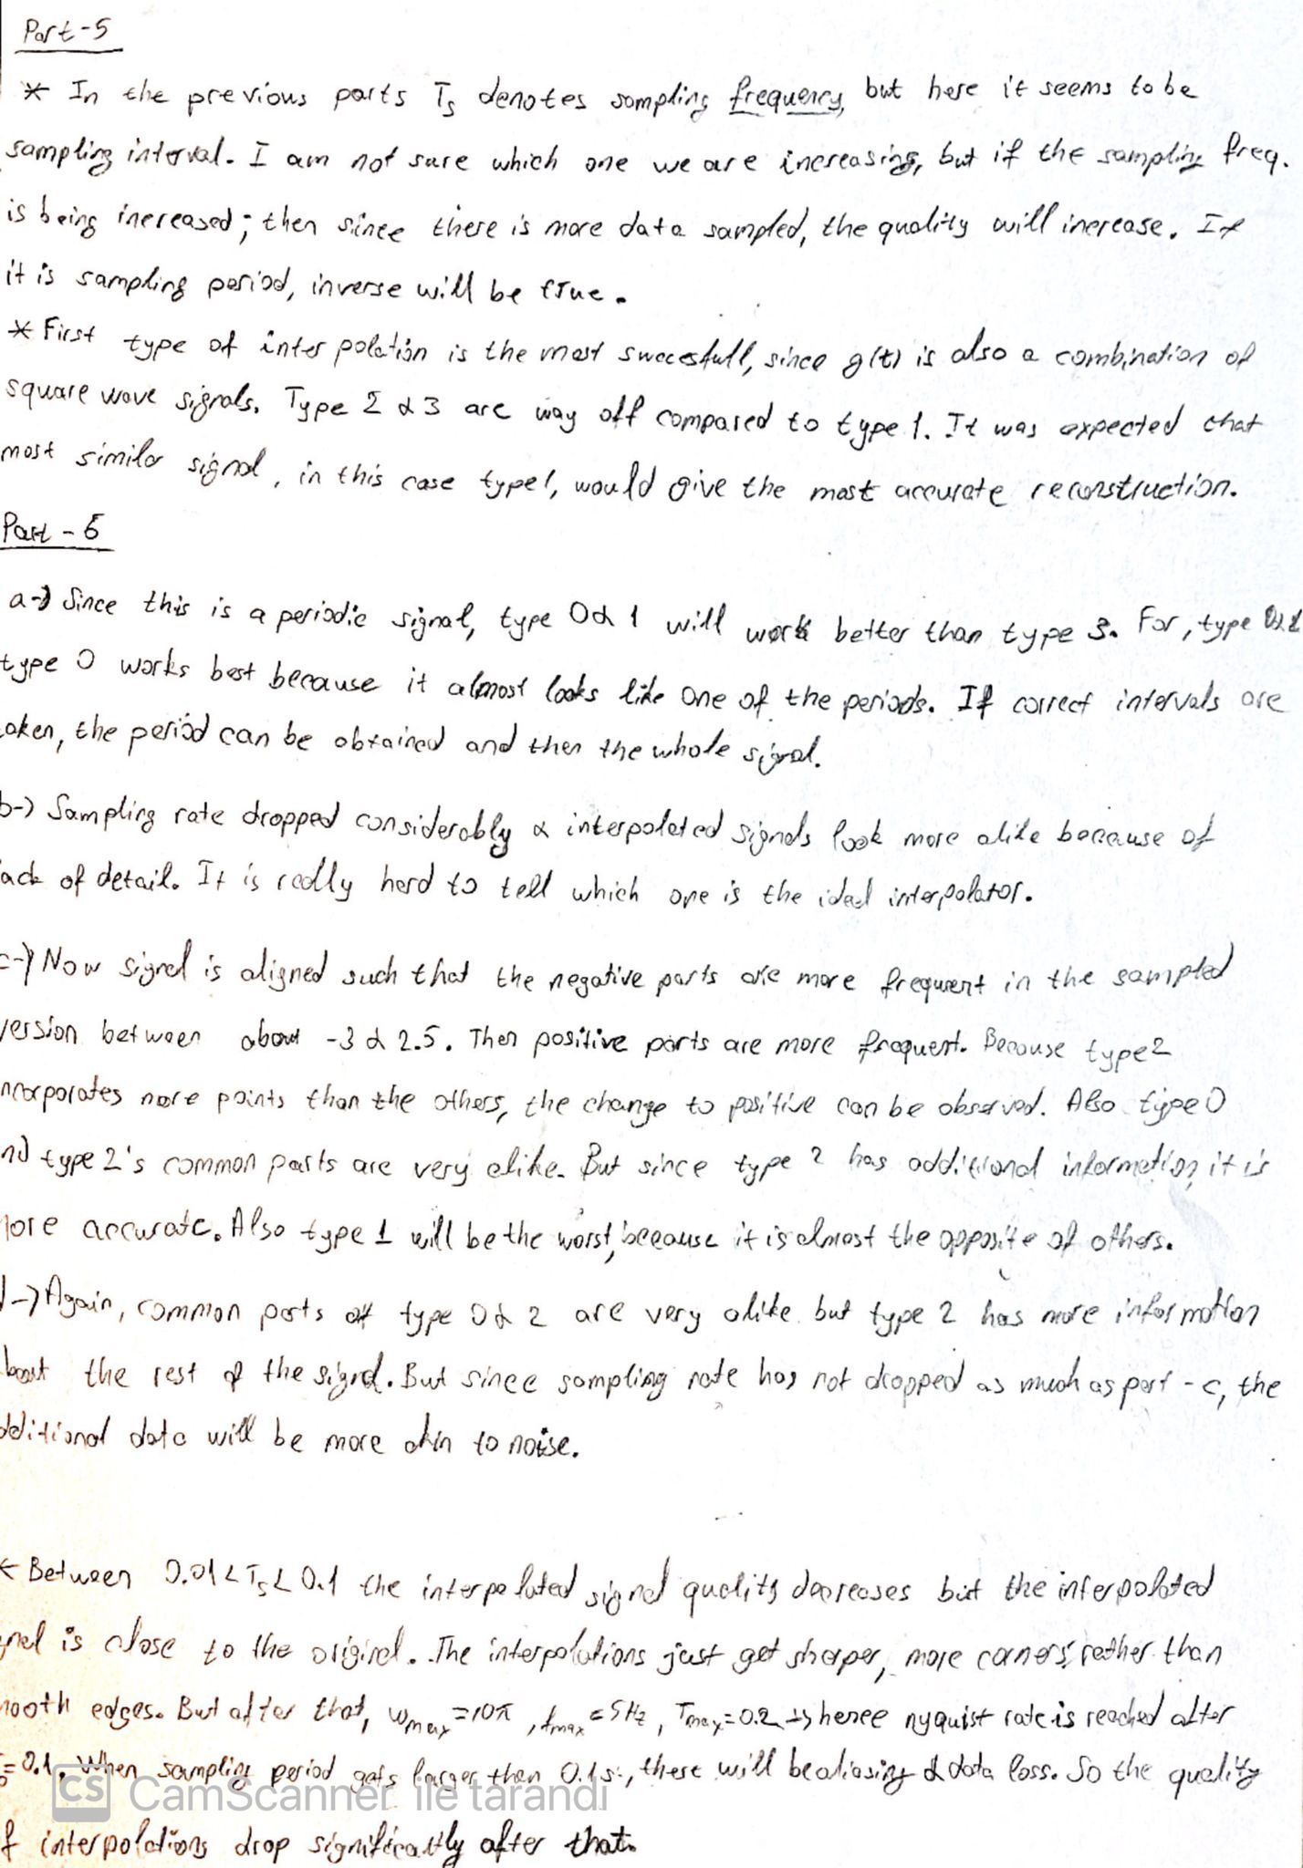

Figure 2- Analytical Part 2

MATLAB Plots

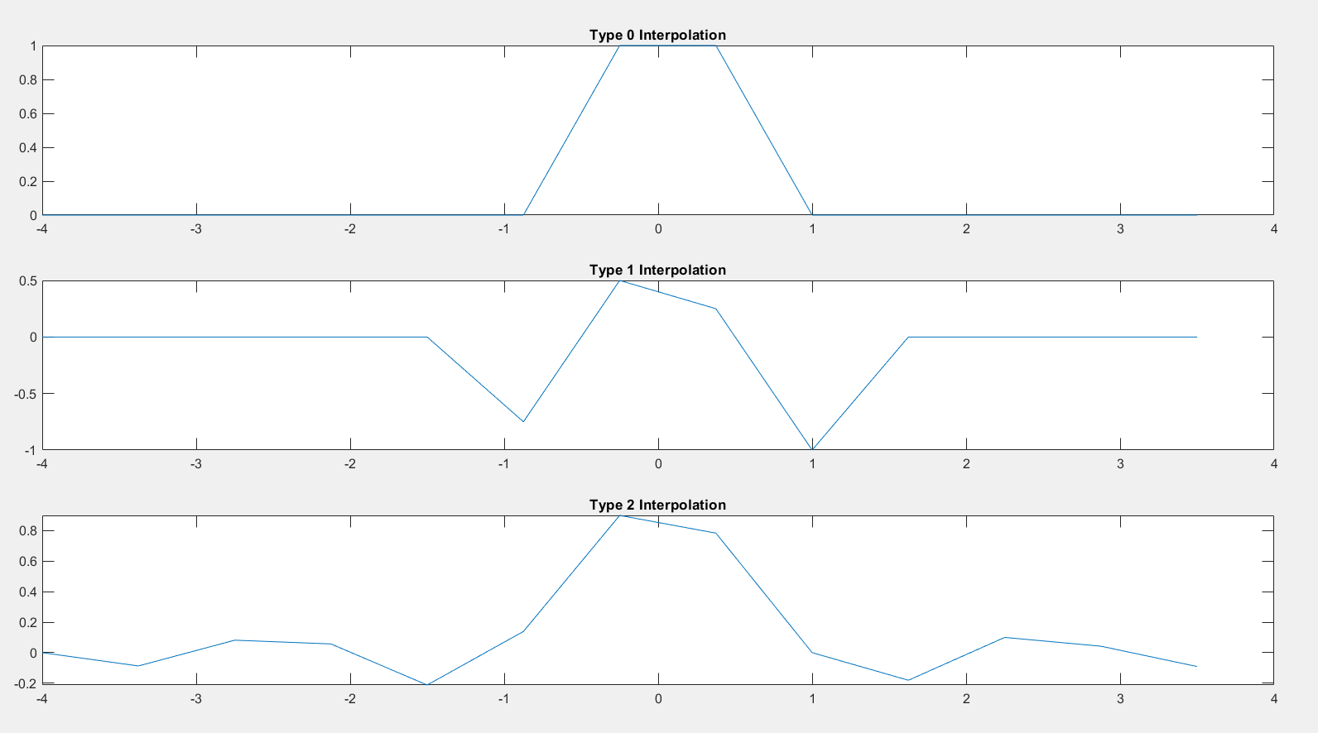

Figure 3- Ts=8/5 Interpolation Graphs

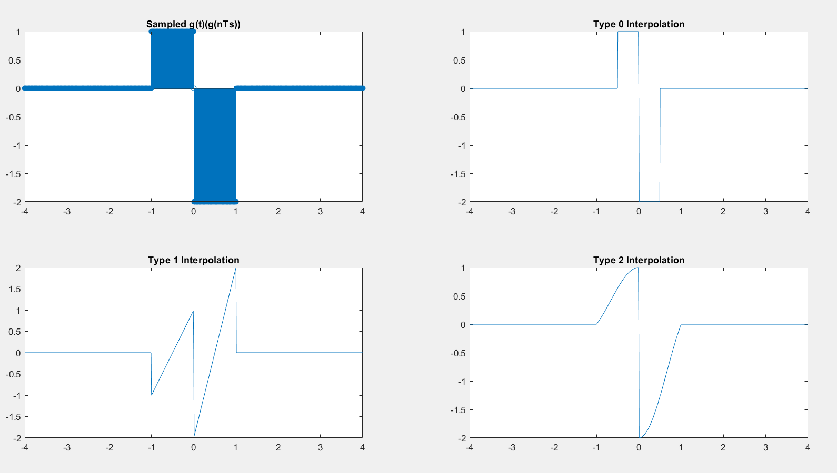

Figure 4- Part 5 Graphs

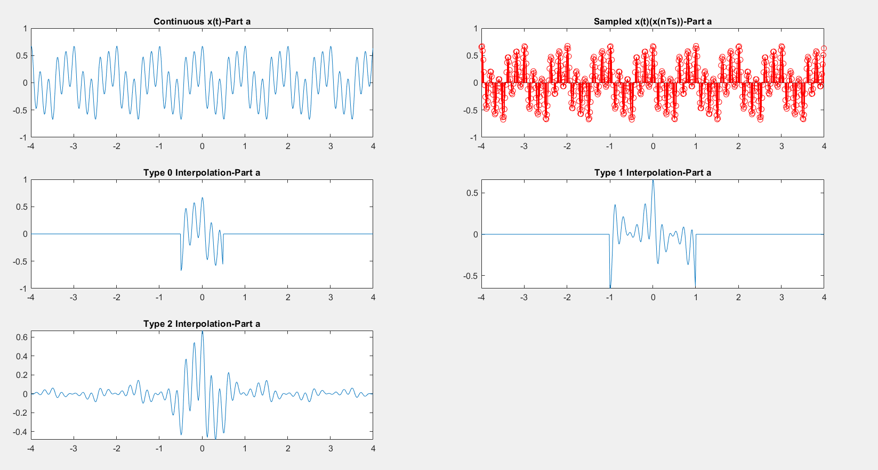

Figure 5- Part 6-A

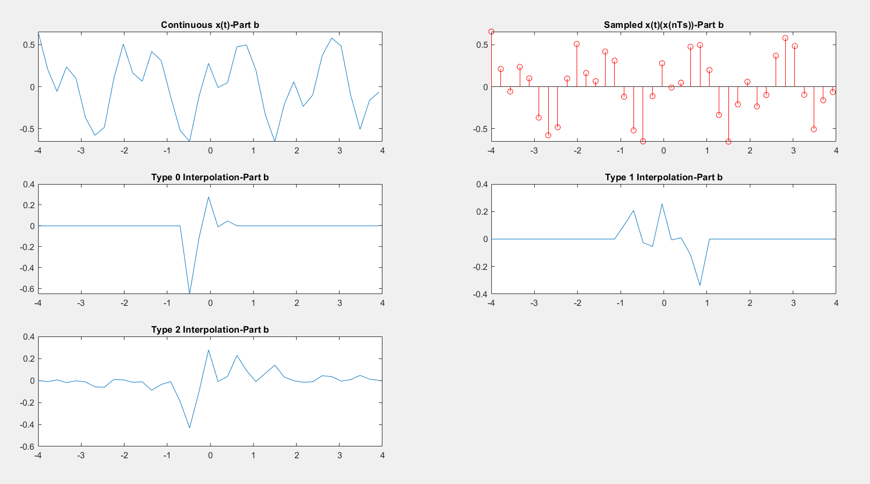

Figure 6- Part 6-B

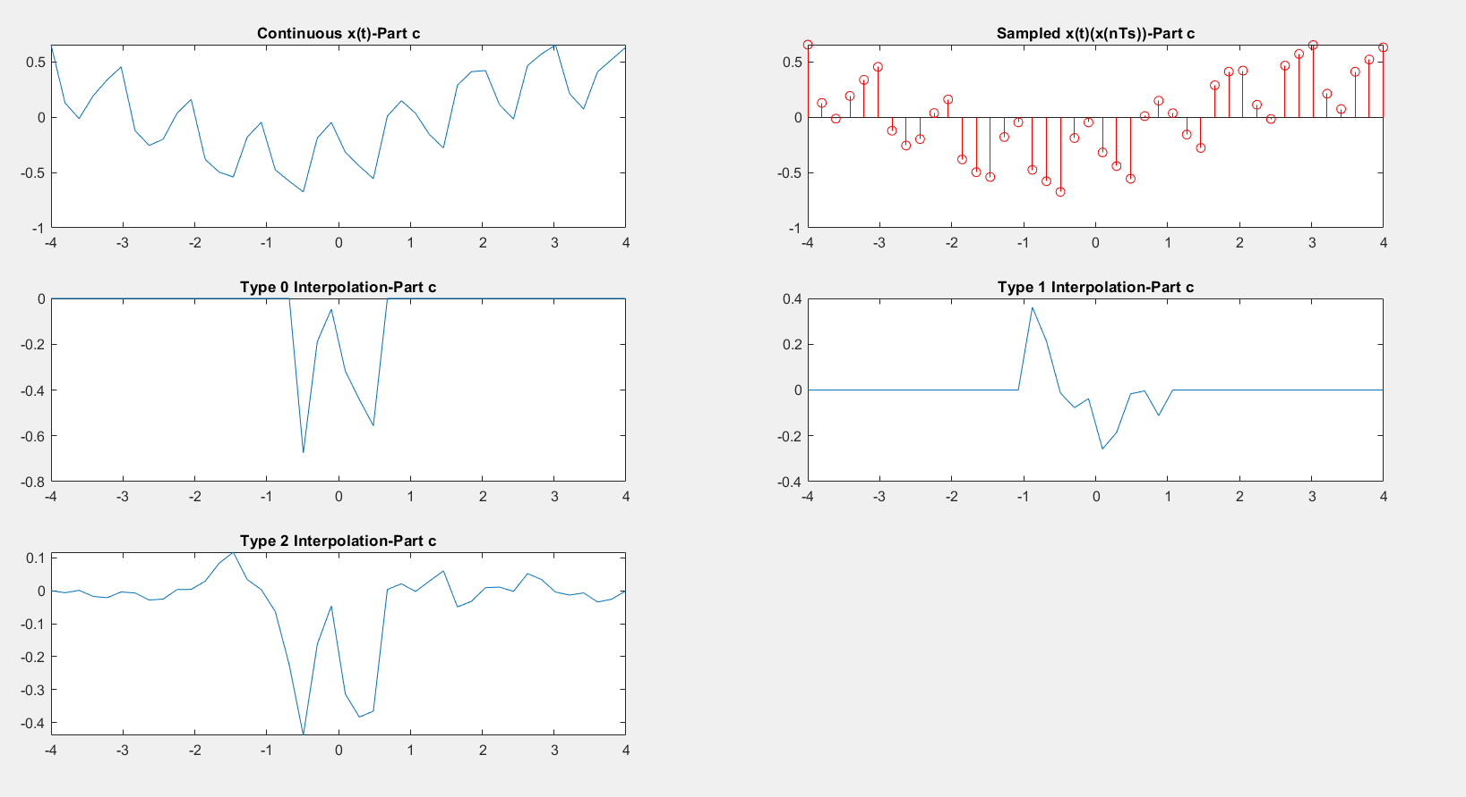

Figure 7- Part 6-C

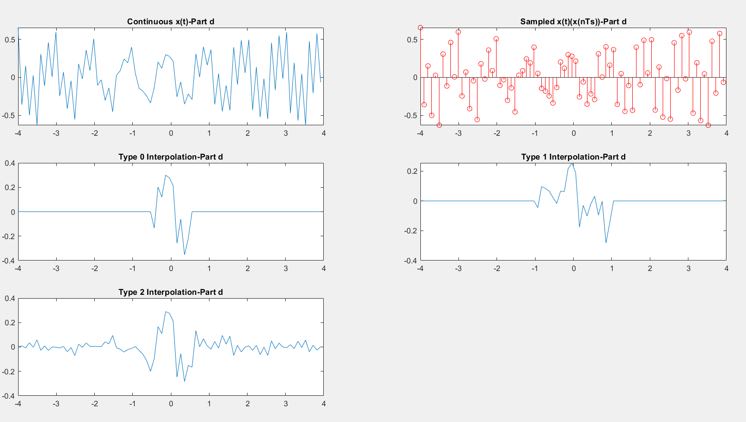

Figure 8- Part 6-D

MATLAB Code

p=generateInterp(0,8/5,8);

dur=8;

Ts=8/5;

type=0;

T0=-dur/2:1/Ts:dur/2;

figure(1)

subplot(3,1,1)

plot(T0,p)

title('Type 0 Interpolation')

subplot(3,1,2)

p=generateInterp(1,8/5,8);

plot(T0,p)

title('Type 1 Interpolation')

subplot(3,1,3)

p=generateInterp(2,8/5,8);

plot(T0,p)

title('Type 2 Interpolation')

r = randi([3 8],1);

Ts1_T=1/(15*r);

Ts1=1/Ts1_T;

type=0;

N=-4:1/Ts1:4;

g_x=zeros(1,length(N));

T_1=(-1<=N & N<0);

T_2=(0<N & N<=1);

g_x(T_1)=g_x(T_1)+1;

g_x(T_2)=g_x(T_2)-2;

dur0=8;

figure(2)

subplot(2,2,1)

stem(N,g_x)

title('Sampled g(t)(g(nTs))')

xR=DtoA(type,Ts1,dur0,g_x);

subplot(2,2,2)

plot(N,xR)

title('Type 0 Interpolation')

subplot(2,2,3)

xR=DtoA(1,Ts1,dur0,g_x);

plot(N,xR)

title('Type 1 Interpolation')

subplot(2,2,4)

xR=DtoA(2,Ts1,dur0,g_x);

plot(N,xR)

title('Type 2 Interpolation')

D=2;

TsX_T=(0.005)*(D+1);

TsX=1/TsX_T;

N0=-4:1/TsX:4;

x_t=zeros(1,length(N0));

T_3=((-4)<=N0 & N0<=4);

x_t(T_3)=x_t(T_3)+(0.3)*cos(2*pi*N0(T_3)+pi/4)+(0.1)*cos(6*pi*N0(T_3)+pi/8)+(0.4)*cos(10*pi*N0(T_3)-1/2);

figure(3)

subplot(3,2,1)

plot(N0,x_t)

title('Continuous x(t)-Part a')

subplot(3,2,2)

stem(N0,x_t,'r')

title('Sampled x(t)(x(nTs))-Part a')

subplot(3,2,3)

xR=DtoA(0,TsX,dur0,x_t);

plot(N0,xR)

title('Type 0 Interpolation-Part a')

subplot(3,2,4)

xR=DtoA(1,TsX,dur0,x_t);

plot(N0,xR)

title('Type 1 Interpolation-Part a')

subplot(3,2,5)

xR=DtoA(2,TsX,dur0,x_t);

plot(N0,xR)

title('Type 2 Interpolation-Part a')

TsX_T=0.2+(0.01)*D;

TsX=1/TsX_T;

N0=-4:1/TsX:4;

x_t=zeros(1,length(N0));

T_3=((-4)<=N0 & N0<=4);

x_t(T_3)=x_t(T_3)+(0.3)*cos(2*pi*N0(T_3)+pi/4)+(0.1)*cos(6*pi*N0(T_3)+pi/8)+(0.4)*cos(10*pi*N0(T_3)-1/2);

figure(4)

subplot(3,2,1)

plot(N0,x_t)

title('Continuous x(t)-Part b')

subplot(3,2,2)

stem(N0,x_t,'r')

title('Sampled x(t)(x(nTs))-Part b')

subplot(3,2,3)

xR=DtoA(0,TsX,dur0,x_t);

plot(N0,xR)

title('Type 0 Interpolation-Part b')

subplot(3,2,4)

xR=DtoA(1,TsX,dur0,x_t);

plot(N0,xR)

title('Type 1 Interpolation-Part b')

subplot(3,2,5)

xR=DtoA(2,TsX,dur0,x_t);

plot(N0,xR)

title('Type 2 Interpolation-Part b')

TsX_T=0.18+(0.005)*(D+1);

TsX=1/TsX_T;

N0=-4:1/TsX:4;

x_t=zeros(1,length(N0));

T_3=((-4)<=N0 & N0<=4);

x_t(T_3)=x_t(T_3)+(0.3)*cos(2*pi*N0(T_3)+pi/4)+(0.1)*cos(6*pi*N0(T_3)+pi/8)+(0.4)*cos(10*pi*N0(T_3)-1/2);

figure(5)

subplot(3,2,1)

plot(N0,x_t)

title('Continuous x(t)-Part c')

subplot(3,2,2)

stem(N0,x_t,'r')

title('Sampled x(t)(x(nTs))-Part c')

subplot(3,2,3)

xR=DtoA(0,TsX,dur0,x_t);

plot(N0,xR)

title('Type 0 Interpolation-Part c')

subplot(3,2,4)

xR=DtoA(1,TsX,dur0,x_t);

plot(N0,xR)

title('Type 1 Interpolation-Part c')

subplot(3,2,5)

xR=DtoA(2,TsX,dur0,x_t);

plot(N0,xR)

title('Type 2 Interpolation-Part c')

TsX_T=0.099;

TsX=1/TsX_T;

N0=-4:1/TsX:4;

x_t=zeros(1,length(N0));

T_3=((-4)<=N0 & N0<=4);

x_t(T_3)=x_t(T_3)+(0.3)*cos(2*pi*N0(T_3)+pi/4)+(0.1)*cos(6*pi*N0(T_3)+pi/8)+(0.4)*cos(10*pi*N0(T_3)-1/2);

figure(6)

subplot(3,2,1)

plot(N0,x_t)

title('Continuous x(t)-Part d')

subplot(3,2,2)

stem(N0,x_t,'r')

title('Sampled x(t)(x(nTs))-Part d')

subplot(3,2,3)

xR=DtoA(0,TsX,dur0,x_t);

plot(N0,xR)

title('Type 0 Interpolation-Part d')

subplot(3,2,4)

xR=DtoA(1,TsX,dur0,x_t);

plot(N0,xR)

title('Type 1 Interpolation-Part d')

subplot(3,2,5)

xR=DtoA(2,TsX,dur0,x_t);

plot(N0,xR)

title('Type 2 Interpolation-Part d')

function p=generateInterp(type,Ts,dur)

T0=-dur/2:1/Ts:dur/2;

p=zeros(1,length(T0));

Tz=((-1/2)<=T0 & T0<=(1/2));

Tl=(-1<=T0 & T0<=1);

Ti=(T0~=0);

Ti1=(T0==0);

if type==0

p(Tz)=p(Tz)+1;

elseif type==1

p(Tl)=p(Tl)+1-2.*abs(T0(Tl));

elseif type==2

p(Ti)=p(Ti)+sin(pi*T0(Ti))./(pi*T0(Ti));

p(Ti1)=p(Ti1)+1;

end

end

function xR=DtoA(type,Ts,dur,Xn)

p_t=generateInterp(type,Ts,dur);

xR=zeros(1,length(p_t));

xR=xR+Xn.*p_t;

end